Project Report: Ride-Hailing Performance Analysis
Date: 3 November 2025
Author: Deewakar kumar
Project: Ride-Hailing Performance Analysis & Insights Dashboard

1. Executive Summary
This project aimed to analyze a raw dataset of 100,000 ride-bookings to extract actionable business insights. The raw data suffered from significant quality issues (e.g., missing values, flawed metrics) that obscured a clear view of business performance.
The data was first cleaned using Python (Pandas), followed by an advanced analysis using SQL to answer 13 key business questions. Finally, all insights were consolidated into a dynamic dashboard.
The key findings show that while the business is robust in Success rides, 'Canceled by Driver' (17.89%) is a major concern. Financially, 'Prime Sedan' (8.8M) is the top-grossing vehicle type. Furthermore, we have successfully identified our most valuable customers (by total spending), which will help refine marketing efforts.

2. Project Objective
The primary objective of this project was to transform raw, unstructured data into a clean, effective analysis to:
- Track key business KPIs (Key Performance Indicators).
- Gain a deeper understanding of revenue streams, customer behavior, and operational challenges.
- Empower the Operations, Marketing, and Strategy teams to make data-driven decisions.

3. Methodology
This project was executed in three distinct phases:
- Data Cleaning (Python): The raw data (Bookings-100000-Rows.xlsx) was loaded into Python (Pandas). Irrelevant columns (like Incomplete_Rides_Reason) were dropped, and missing values (in Driver_Ratings, V_TAT, etc.) were imputed using 'median' and 'mode'. The clean data was exported as cleaned_bookings.csv.
- Data Analysis (SQL): The clean data was loaded into a SQL database. 13 SQL queries were written to address specific business requirements (e.g., Top Customers, Failed Booking Reasons, Busiest Hours).
- Data Visualization (Dashboard): The results from the SQL analysis were visualized in an interactive dashboard (e.g., Power BI, Tableau) to make the insights easy to understand.

4. Key Findings & Analysis
The dashboard revealed 4 main insights into the business's performance:
4.1. Insight 1: Booking Status Overview (Operational Health)
The 'Total Booking by Booking Status' chart provides a clear view of the company's operational health.
- Success (62.08%): This is a strong number, indicating the majority of bookings are completed successfully.
- Canceled by Driver (17.89%): This is the most significant problem. Nearly 18% of all rides fail due to driver cancellations, leading to customer dissatisfaction and lost revenue.
- Driver Not Found (9.83%): This is another key metric, suggesting a potential lack of driver supply in high-demand areas.

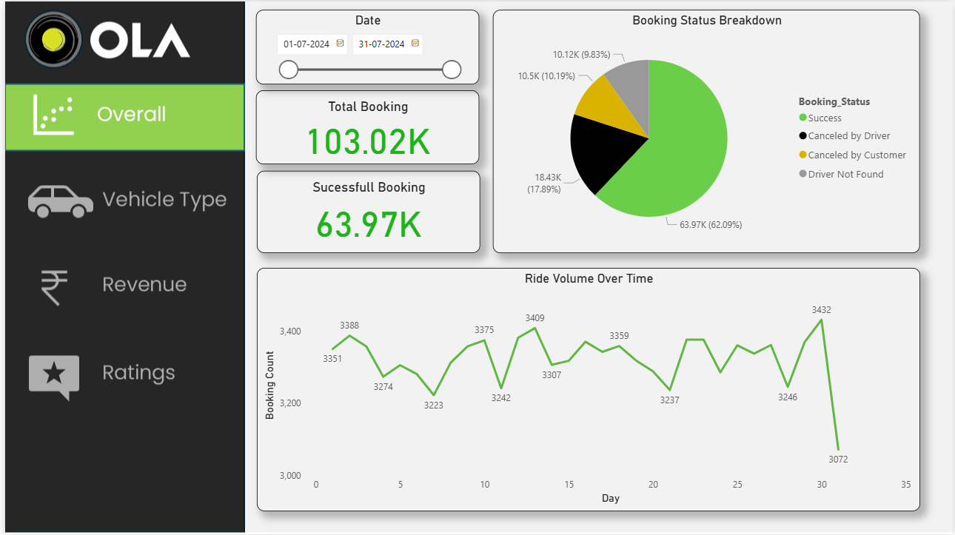
4.2. Insight 2: Revenue Drivers (Financial Performance)
The 'Total Revenue by Vehicle Type' chart clearly identifies where the company's revenue originates.
- Prime Sedan (8.8M): This vehicle type is the largest source of revenue. It is a critical segment to maintain and grow.
- Prime SUV (5.5M): This is the second most important segment.
- Bike / eBike: Their revenue contribution is minimal, likely due to shorter-distance trips or lower price points.

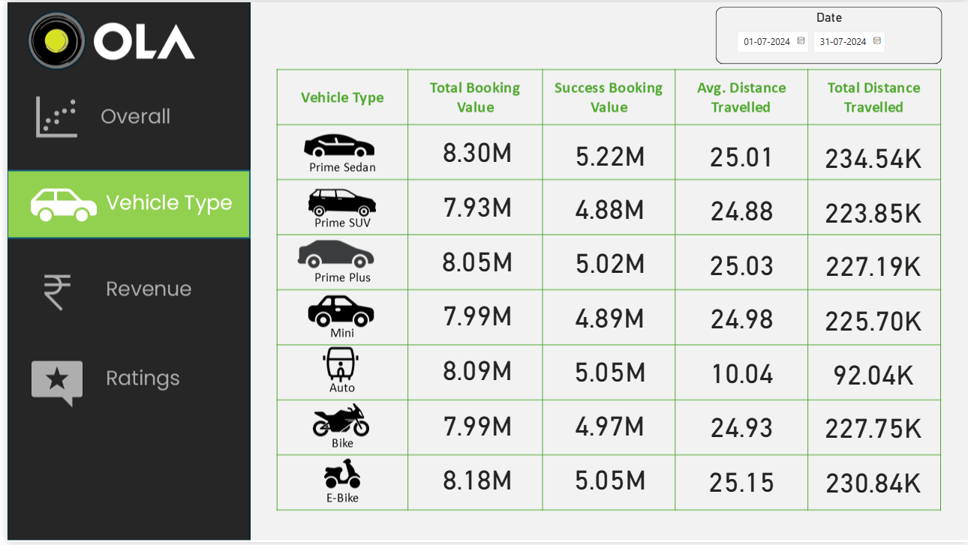

4.3. Insight 3: High-Value Customer Identification (Marketing Focus)
Initially, "Top Customers" were being tracked by their booking count, which was a flawed metric as it included canceled rides.
The new "Top 5 Customers by Total Spending" chart now correctly uses the Sum of Booking_Value (for 'Success' rides only). This has provided a true list of our most valuable customers. Customer CID995321 is the most valuable, having spent 77.3K.

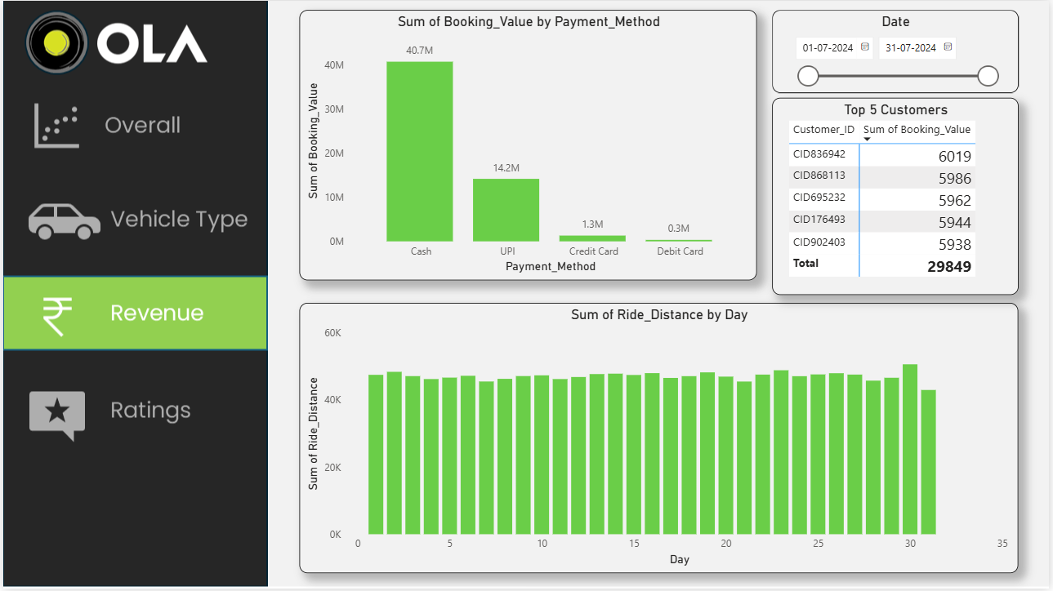

4.4. Insight 4: Demand Hotspots (Operational Focus)
The "Top 5 Pickup Location" chart identifies the areas with the highest demand, or 'hotspots'.
- 'Whitefield', 'Marathahalli', and 'Electronic City' are the top 3 locations.
- This data is crucial for the Operations team. By allocating more drivers to these areas during peak hours, we can reduce the 'Driver Not Found' rate and increase revenue.
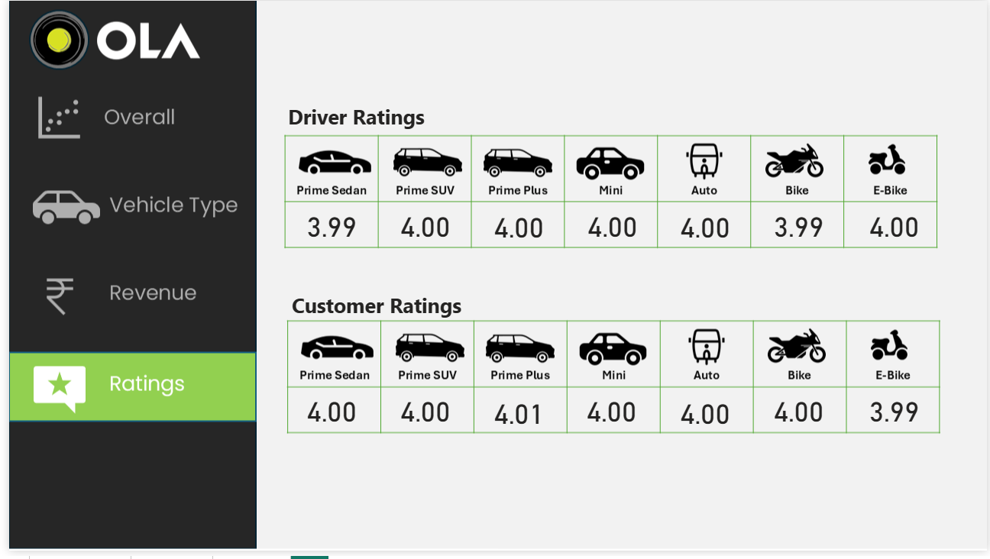

5. Actionable Recommendations
Based on this analysis, the following recommendations are proposed to improve the business:
- Reduce Driver Cancellations: The Operations team must immediately investigate the high 'Canceled by Driver' (17.89%) rate. Use SQL query #12 (High Driver Cancellation Locations) to identify which locations are most affected and survey drivers to find the root cause (e.g., traffic, payment issues, safety).
- Focus on 'Prime Sedan': The Marketing team should promote the 'Prime Sedan' segment. Special incentives could be offered to drivers in this category.
- Implement Loyalty Program: The Marketing team should create a loyalty program or offer special discounts for the "Top 5 Customers by Total Spending" (identified in Insight 3) to ensure their retention.
- Optimize Driver Allocation: The Operations team should use the "Top 5 Pickup Locations" (Insight 4) data to ensure high driver availability in these hotspots, especially during peak hours.

6. Conclusion
This project has been successful in transforming a messy, raw dataset of 100,000 bookings into a powerful decision-making tool. The process of data cleaning with Python, deep analysis with 13 SQL queries, and visualization in a clear dashboard has provided a clear path for the business to increase revenue, improve operational efficiency, and better understand its customers.

